Uganda Hunger Story Review

Progress and general stats:
- Prevalence of Undernourishment
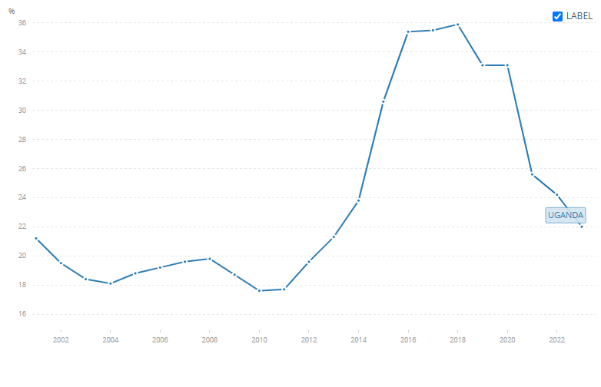(FAO STAT)
- The progress that has been seen in the past few years is, in reality, a return to the normal state of undernourishment
- The largest single driver of the undernourishment spike in the 2010s is the massive influx of refugees
  - The South Sudan war was reignited in 2013, which coincides with the spike in PoU
  - 2019: “Around nine in 10 refugee households experience moderate to severe food insecurity, while this is the case for six in 10 hosts.” (WB Blog)
  - Covid Pandemic compounded this: (WB Blog)
    - 2021: poverty rate among refugees is projected to be around 50%
    - 2021: About 64 percent of refugees are food insecure compared with 9 percent of Ugandans
  - After the South Sudan conflict entered a lull, refugee intake eased in 2019
- There are agricultural improvement plans in place
  - Uganda Climate-Smart Agricultural Transformation Project (UCSATP), operationalized 25 June 2024
    - To increase productivity, market access and resilience of select value chains in the project area.
    - Improve seed systems, agro-climatic information, and adoption of Climate-Smart Agri. Technologies and value chains.
    - This could be an interesting piece to look at, specifically the agro-climatic information and data
    - Moderately unsatisfactory progress toward targeted outcome as of Mar 22, 2026 (ISR Doc)
      - Due to delays in fund flows, slow procurement execution,
      - However, moderately satisfactory in term of Strengthening Climate-Smart Ag research, and seed and Agro-Climatic Information systems
  - FAO Hand-in-Hand Initiative (Milk and Maize Value Chains) (
    - Proposes four milk processing facilities, six modern milk tanker trucks, and 100 milk coolers. Annual production targets include 139 million liters of UHT milk and 70 million liters of pasteurized milk.
    - Focus on maize quality, cleaning, storage, and value-added processing (cornflakes, maize oil, maize starch)
- Paragraph:
  - Uganda's undernourishment trajectory over 2013–2024 reflects two concurrent shocks and their partial unwinding, rather than any meaningful development progress. The spike from 19.6% (2013) to 35.9% (2019) was driven by two forces hitting simultaneously: the 2016–2017 El Niño-linked drought, which devastated Uganda's predominantly rain-fed agricultural sector and pushed over 10 million people into food insecurity, and a massive refugee influx — primarily from South Sudan's civil war — that swelled Uganda's refugee population from roughly 250,000 to 1.4 million faster than WFP could scale up food assistance to match, adding to the population denominator without a corresponding increase in food supply. The subsequent decline to 22.0% by 2024 is primarily a drought-recovery story: rainfall normalised from 2019 onward, agricultural growth rebounded to 4.3–4.4% annually through FY2021/22, and the sharp statistical drop between the 2021 and 2022 FAO readings (33.1% to 25.6%) is largely a mechanical artefact of the 3-year rolling average methodology washing out the two worst drought years simultaneously. Secondary factors — post-COVID economic normalisation and modest income growth — contributed marginally, while the refugee population, now more gradually growing (1.4M to 1.8M) but subject to severe WFP ration cuts, shifted from an adverse driver to a small ongoing headwind. Crucially, Uganda's 2024 PoU of 22% remains above its pre-shock 2013 level, structural vulnerabilities are entirely unchanged — 81% rain-fed dependency, just 0.5% irrigated land — and below-average rainfall in 2022/23 immediately slowed agricultural growth back to under 2%, confirming that what looks like progress is largely climatic normalisation, not durable transformation.

